**Hospital Management System**

- by Akhil Tavva

(IMT2020124)

Use Case Diagram

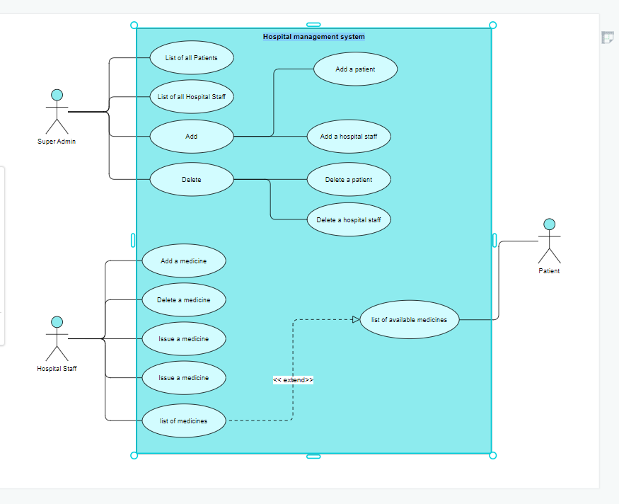

UML Diagram

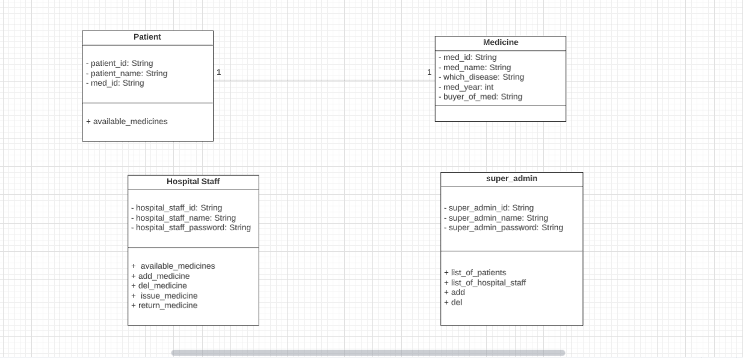

OR Mapping

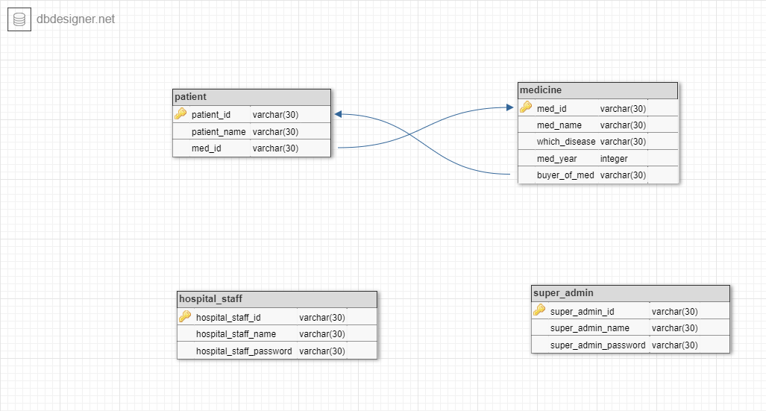

Output Screenshots

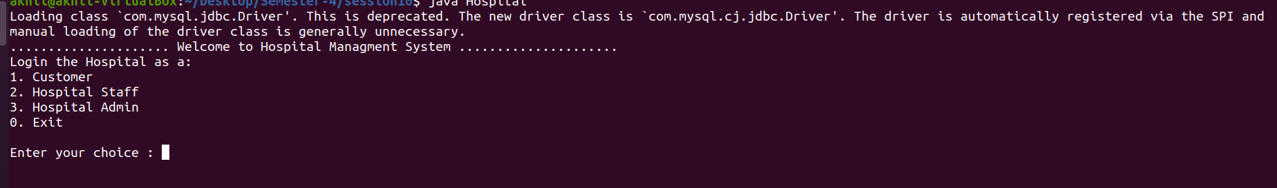Main Menu

Customer/patient Menu

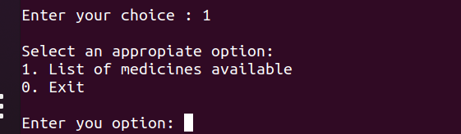

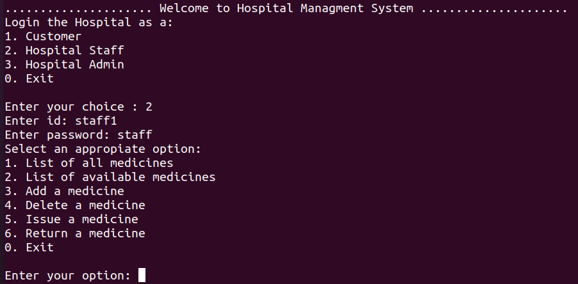

Hospital Staff menu

Super Admin Menu

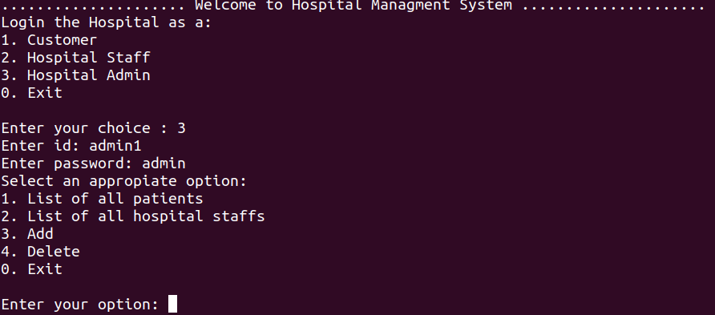

List of all medicines

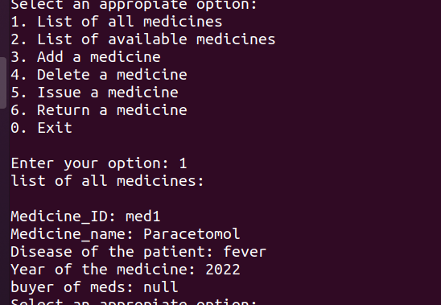

List of available medicine

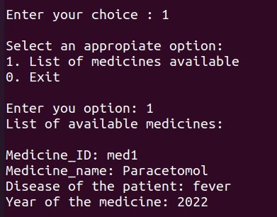

Add a medicine

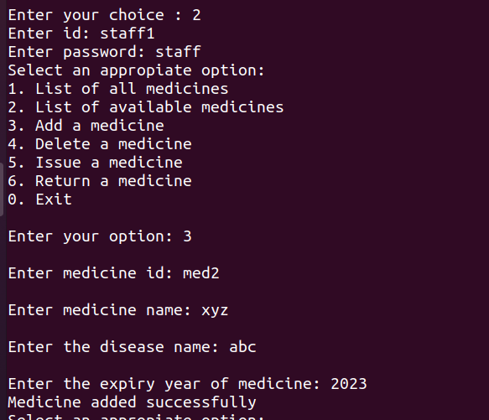

Delete a medicine

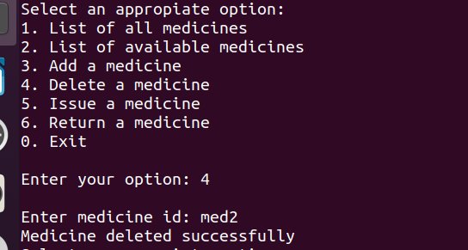

List of all patients

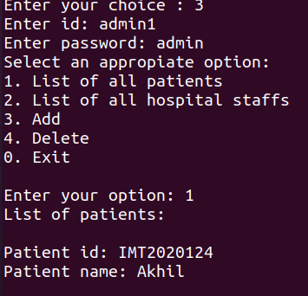

List of all hospital staffs

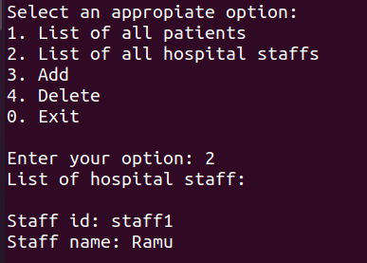

Instructions to run the code

⇒ First of all, create a user root with a password as admin. The command to do is:

CREATE USER ‘root’@’localhost’ IDENTIFIED BY ‘admin’;

⇒ After that, we have to use the source in MySQL by writing the path of create, alter and insert SQL files. Command is

source sql/Hospital_create.sql

source sql/Hospital_alter.sql

source sql/Hospital_insert.sql

⇒ After everything is done, if you want to drop the database in MYSQL then use this command:

source sql/ Hospital_drop.sql

⇒ Now we have to run these on the terminal:-

1.export CLASSPATH='/home/akhil/Desktop/Semester-4/session10/mysql-connector-java-8.0.18.jar:.'

2. javac Hospital.java

3. java Hospital

⇒super_admin credentials:

Id: admin1

Password: admin

⇒hospital_staff credentials:

Id: staff1

Password: staff